How to send Final grades to Principal
- Login to www.engradewv.com
- Choose your class
- Left hand side choose marking period
- Select Grading Period in the first drop down box
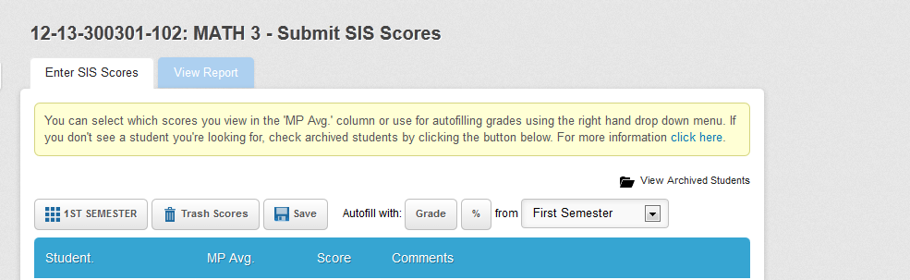
- Choose matching grading period in the 2nd drop down box

- Choose “percent” for 9 week grades
- Choose “Grade” for semester grades
- Insert a P or F for pass/fail grades on this page
- Click SAVE
- Check your grade report by clicking on the tab at the top: “View Report”
- Do for all classes Grades 3 through 6
Revised Jan 15 2013

